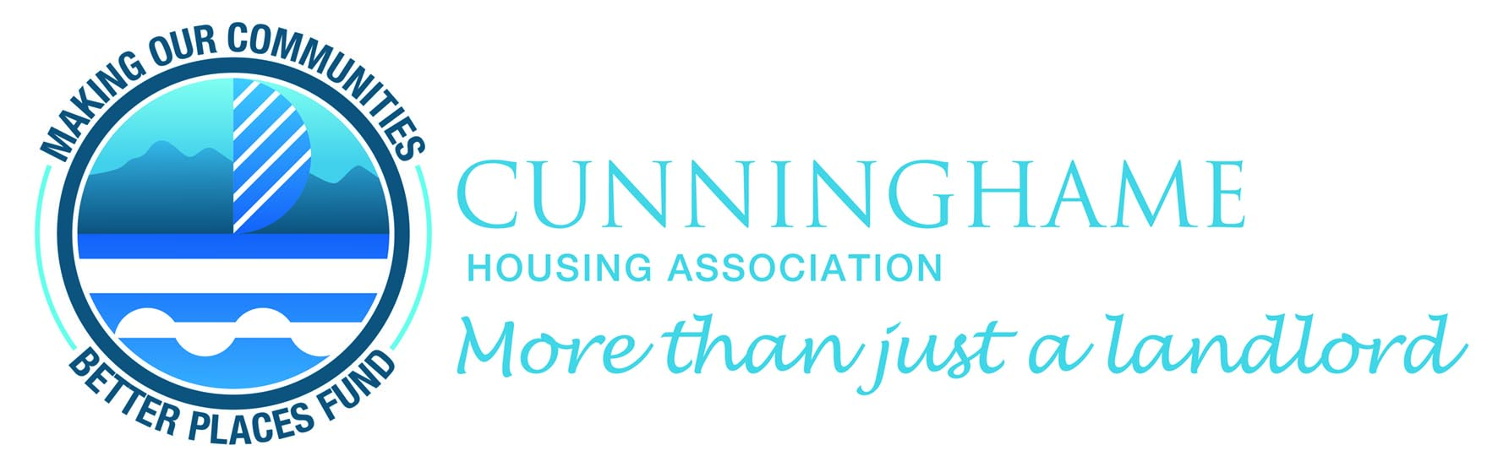

APPLICATION FORM

Please complete and return to Kirsteen Wyllie or Elaine Nimmo at the Group Chief Executives Office of Cunninghame Housing Association Ltd., Quayside Offices, Marina Quay, Dock Road, Ardrossan KA22 8DA. Tel No: 01294 607572 or e-mail: kwyllie@chaltd.org or enimmo@chaltd.org. This form is also available on our website: www.cunninghame-housing.org.

Please note that only one application for funding will be considered by the Board of Management in any one financial year.

Organisation/Individual Name:

Type of Organisation:

Charity Registration Number
(if applicable)

Address
Address | Postcode:

Telephone Number:

Email:

- Please provide details of your organisation

- Please provide details of what you are seeking funding for

- Please provide details of what the funding will be used for and a breakdown of the costs.

- Please give details of who will benefit from the funding and the direct benefits to the communities.

Please note our maximum funding for any project within a 12-month period is £1,000

- How much funding are your requesting from Cunninghame Housing Association?

- Have you already secured other funding for this project?
Yes ◻

No ◻

If yes, please provide details

- Will your organisation/individual proceed without our funding?
Yes ◻

No ◻

- How are you planning on raising the total amount needed?
Other grants ◻
Donations ◻
Fundraising events(s) ◻
Other ◻

- What geographical area do you operate within?
Dumfries and Galloway
North Ayrshire ◻ Annan ◻
East Ayrshire ◻ Gretna ◻
Lockerbie ◻
Eastriggs ◻

- To your knowledge is anyone involved in your organisation related to or known to any of Cunninghame Housing Association’s Board of Management or Staff?

- Is your organisation run by a voluntary committee?
Yes ◻

No ◻
If yes, please provide the names of the following people:

Chairperson ______________________________________________

Vice Chairperson ______________________________________________

Secretary ______________________________________________

Treasurer ______________________________________________

FINANCIAL INFORMATION

- Please provide the following information:
Name of Bank: ______________________________________________

Name on Bank Account: ______________________________________________

Bank Account No: ____________________ Sort code: _______________

Name of Authorised Signatories

Please provide a copy of your last 3 months bank statement.
How did you find out about Cunninghame Housing Association’s funding application?
Facebook ◻

Website ◻

Newsletter ◻

Other ◻

If other, please provide details

Signed: |  | Date:

Checklist

Have you completed all the questions on the form or if not applicable marked as n/a? | ◻
Have you enclosed a copy of last 3 months bank statements? | ◻
Have you signed and dated the application form? | ◻

What happens after you apply?
- You send us your application – we'll get back to you with a decision after the Board of Management has considered your application. During the process we look at your application and do our security checks. We might give you a call to talk a little more about your application or ask for more information.
- If your application is successful – we'll write to you with the good news and arrange for a cheque presentation. We will arrange for a press release with a photograph of the cheque presentation to share your good news. This will be shared on our website, social media and within local newspapers.
- If your application is unsuccessful – we will write to you and advising same. You can submit a new application for consideration to the Association in the next financial year.

Any personal data provided as part of your application or award will be used solely for the purpose of considering your application and making an award where appropriate. This is necessary to allow us to consider entering in to a funding arrangement with you, and to meet the conditions/criteria of any award made. Any feedback provided following an application will be used for improving our processes for future applicants where it is in the legitimate interests of the Association, and only where doing so does not override your own interests. Further information on how we process your personal data is available in our privacy policy at www.cunninghame-housing.org or by contacting us.

